Owl Fest
November 13th and 14th, 2026
Owl Fest is a special event made possible with partner organizations including the U.S. Army Corps of Engineers, Caesar Creek State Park, Friends of Caesar Creek, Nature Center Association of Caesar Creek, and the Ohio School of Falconry.

Friday, November 13th
Meet in the Caesar Creek Lake Visitor Center Learning Center.
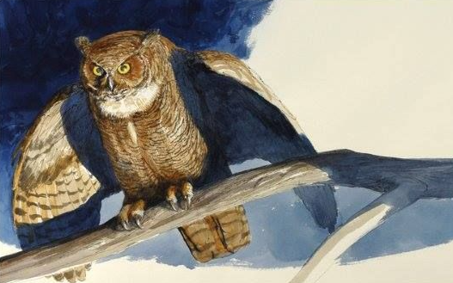
7:30 pm – Owl Moon
We will begin with the story, Owl Moon, which tells of a father and daughter on a winter hike in search of a Great-Horned Owl. After the story, we will go outside in search of Caesar Creek owl species. In November, owls re-establish territories and prepare for nesting. Please dress for the weather.
9:00 pm – Owl Banding Demonstration
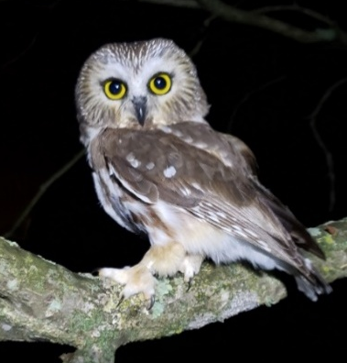
Local bird banders will also be on site banding Northern Saw-whet Owls. See bird banding research in action and learn about these seldom-seen owls. Drink hot chocolate and apple cider provided by Friends of Caesar Creek. This event is weather dependent.
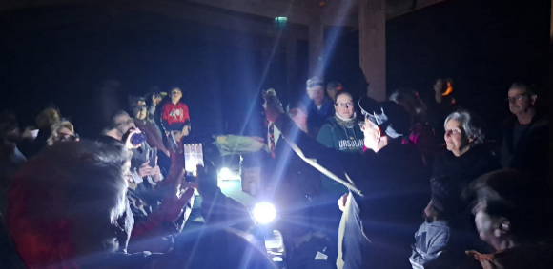

Saturday, November 14th
Meet in the Caesar Creek Lake Visitor Center Learning Center.

4:00 pm –6:00 pm – Owl Box Workshop
Build your own Owl Box to take home with the Nature Center Association of Caesar Creek (NCACC). Learn why birds are important, how to attract them to your yard, how to help protect them, and how to monitor your bird box. Kits are ready to assemble. All materials and tools needed will be supplied during the workshop for a fee of $35 (limited kits available). All proceeds go to NCACC, and all profits are used to help care for the Nature Center Wildlife and to help support other park programs.
6:00 pm – Owl Flight Demonstration
Ohio School of Falconry will show off a variety of birds of prey. Learn about and meet birds from around the world!
8:00 pm –Northern Saw-Whet Owl Research
Learn about the Northern Saw-Whet Owl research at Caesar Creek Lake including why we study these birds, their life history, and bird banding/ radio telemetry.
9:00 pm – Owl Banding Demonstration Local bird banders will also be on site banding Northern Saw-whet Owls. See bird banding research in action and learn about these seldom-seen owls. Drink hot chocolate and apple cider provided by Friends of Caesar Creek. This event is weather dependent.

